ADVERTISEMENT FOR BIDDING

The University of North Carolina at Charlotte is soliciting bid proposals from pre-qualified contractors for the Emergency Power project. Estimated construction costs are $265,000. Sealed proposals will be received from pre-qualified general contractors for single prime construction until 2:00 P.M., EST on Tuesday, January 22nd, 2013, in Room 119 of the Facilities Management/Police building on the UNC Charlotte Campus (Building #55a on the campus map). Pre-qualified General Contractors include:

Messer Construction Company
Watson Electric
Whiting-Turner Contracting Co.

Compliance with “Guidelines for Recruitment and Selection of Minority Businesses for Participation in State Construction Contracts” shall apply for this project.

A mandatory pre-bid meeting will be held at 8:30am on Tuesday, January 8th, 2013 in Room 113 of the Cone University Center (see map, below). Public parking is available in the Cone Deck. Please contact the Project Manager for the project, Brian Kugler at 704.687.0522 if there are questions about the meeting location.

The meeting will address preferred brand alternates and their performance standards that the Owner will consider for approval on this project, project specific questions, issues, bidding procedures and bid forms. An optional walk of the site will follow.

In accordance with GS133-3 and SCO procedures the following preferred brand items are being considered as Alternates by the owner for this project:

N/A

Complete plans, specifications and contract documents may be obtained by pre-qualified contractors from Rich Manning, United Engineering Group, Inc, 5624 Executive Center Drive, Suite 200, Charlotte, NC 28212, Monday - Friday between 9:00am and 5:00pm. Deposit is $75.00. They will also be open for inspection in the offices of Facility Management - Capital Section at UNC Charlotte, United Engineering Group, Inc. and in the plan rooms of:

Associated General Contractors, Carolinas Branch, Charlotte;

North Carolina, McGraw-Hill Dodge Corporation, Charlotte;

Eastern Regional Office of Reed Construction Data, Charlotte;

Minority Plan Rooms in

Hispanic Contractors Association of the Carolinas (HCAC)

Winston-Salem, Charlotte, and Raleigh Areas

877-227-1680

Minority Contractors Resource Center

125 Erwin Avenue

Charlotte, NC 28202

Ph. 704-332-9383 Fax 800-884-8679

The State reserves the unqualified right to reject any and all proposals.

Prior to the public bid opening, sealed proposals may be delivered to Ms. Joyce Clay at Facilities Management, Capital Section, UNC Charlotte, and 9201 University City Boulevard, Charlotte, NC 28223-0002.

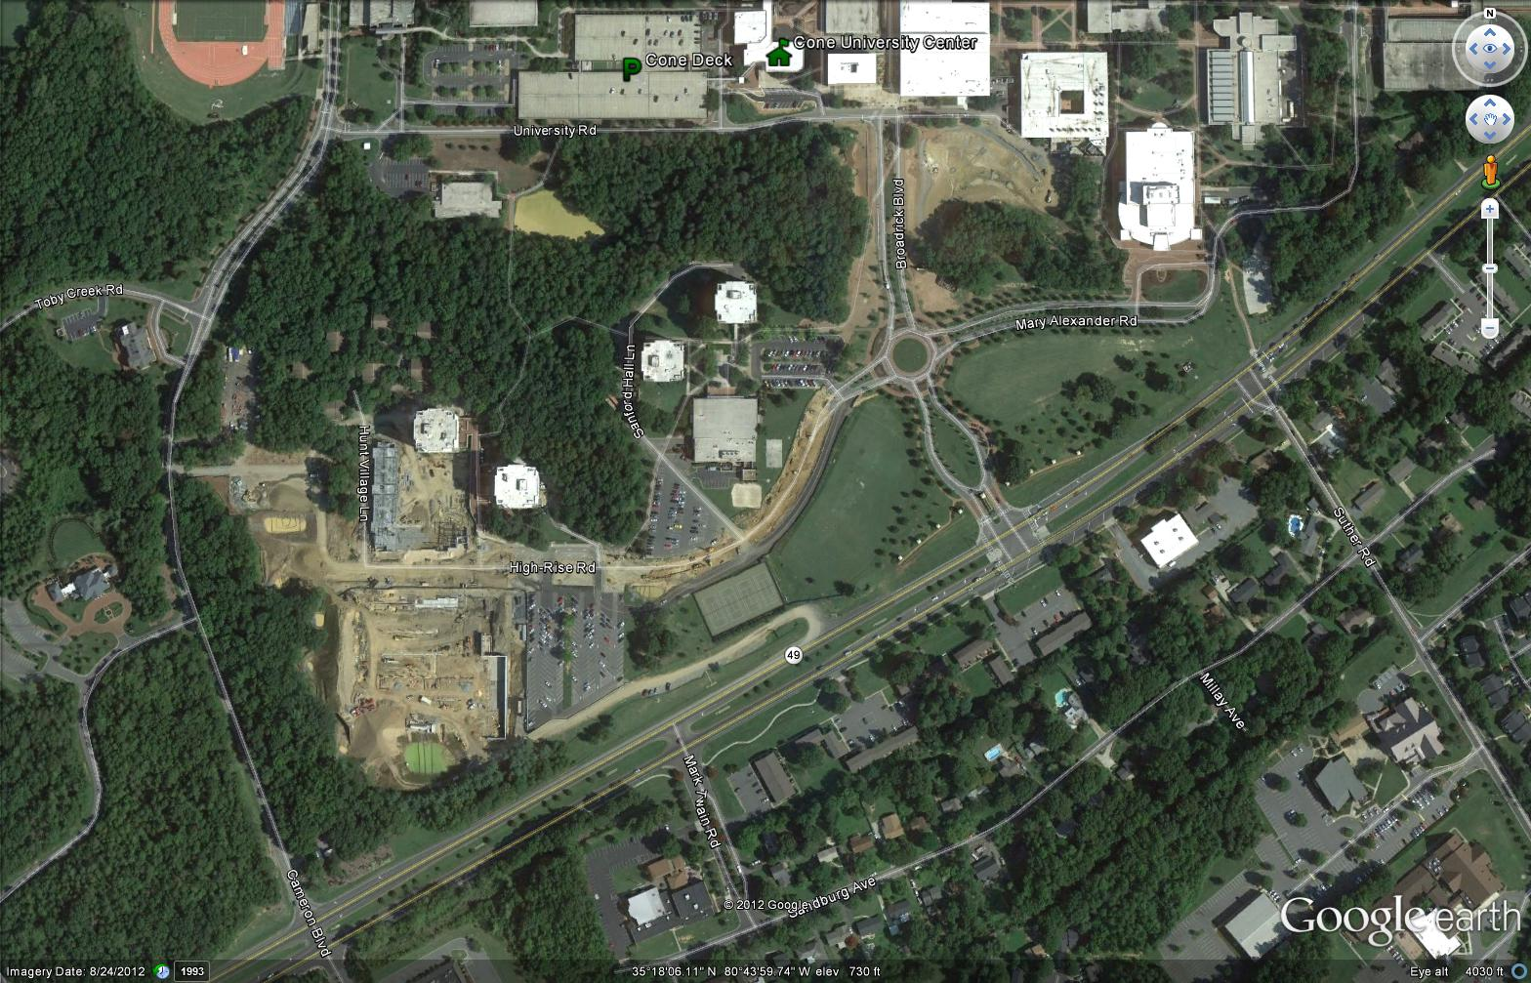
The pre-bid meeting will take place in Cone University Center in Room 113 and will begin promptly at 8:30am.

